Project Design Phase-II
Data Flow Diagram & User Stories

Date | 30 JUNE 2026
Team ID | SWTID-2026-1795
Project Name | HEART DISEASE ANALYSIS
Maximum Marks

Data Flow Diagrams:
A Data Flow Diagram (DFD) is a traditional visual representation of the information flows within a system. A neat and clear DFD can depict the right amount of the system requirement graphically. It shows how data enters and leaves the system, what changes the information, and where data is stored.
EXAMPLE:
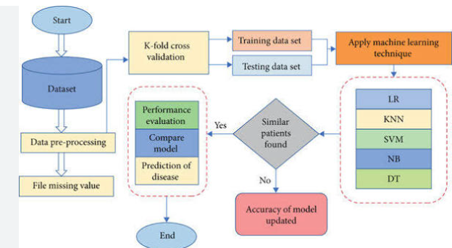
User Stories
Use the below template to list all the user stories for the product.
User Type | Functional Requirement (Epic) | User Story Number | User Story / Task | Acceptance criteria | Priority | Release
Healthcare Analyst | Data Integration | USN-1 | As an analyst, I can connect Tableau to the clinical SQL database securely. | Secure live connection is established with no data loss. | High | Sprint-1
 |  | USN-2 | As an analyst, I can blend demographic tables with biometric lab data. | Patient ID successfully maps metrics across different source tables. | High | Sprint-1
 | Biometric Profiling | USN-3 | As an analyst, I want to see a distribution chart of patient serum cholesterol. | A dynamic histogram showing clean distribution bins of cholesterol. | Medium | Sprint-1
 |  | USN-4 | As an analyst, I want a scatter plot comparing blood pressure against age. | Visual markers correctly isolate clinical risk thresholds. | Medium | Sprint-2
 | Dashboard Assembly | USN-5 | As an analyst, I can create an executive summaries view combining key charts. | All charts display on a single dashboard layout cleanly. | High | Sprint-2

